Photo Story
http://www.microsoft.com/windowsxp/using/digitalphotography/photostory/default.mspx
Opening Photo Story
Click Start, point to All Programs, and then click Photo Story 3 for Windows. On the Welcome page, click Begin a new story for a new project, or click Edit a project to continue to working on one you have already started. Then click Next.

Adding Pictures
Click Import Pictures.
Browse to your folder of choice. To add more than one picture at a time, press and hold the CTRL key and click on the pictures you want to add, and then click OK. Pressing the Control and A keys at the same time will select all of the pictures in the folder you selected. All of your pictures should now be present in the filmstrip at the bottom of the window.

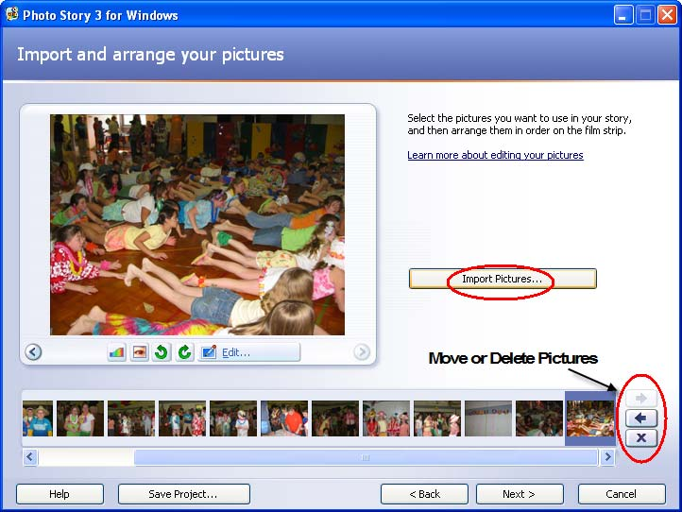

Use the arrows to the right to move pictures around on the filmstrip. You can also delete pictures at this point.

Editing Pictures
First click on one of your pictures in the timeline. Then click the Edit button.

(There are also some quick edit buttons to the left of the Edit button.)
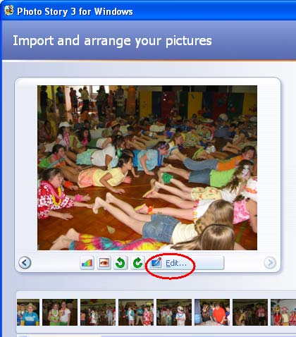

The Color Levels button makes adjustments to color problems.

The redeye button attempts to correct redeye.

The 2 green arrows rotate the picture right or left.

The first tab is the Rotate and Crop screen. 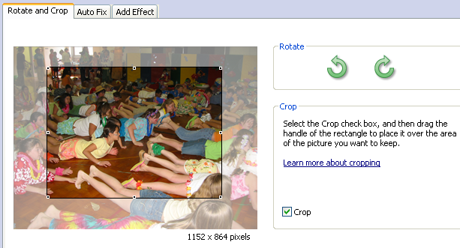

Check the Crop checkbox and a rectangle appears over the picture. Drag the rectangle until it covers the section you want to crop and click Save. The green arrows allow you to rotate the picture either clockwise or counterclockwise.

The second tab is the Auto Fix tab.

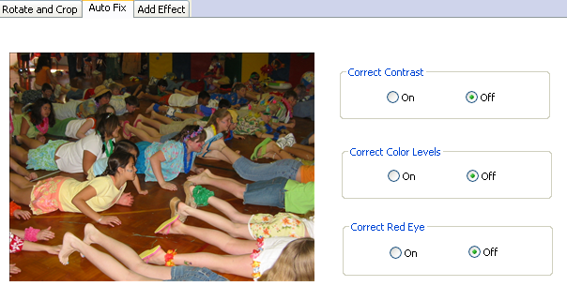

Click the radio buttons to determine whether or not you like the corrections
Photo Story makes to your image.

The third tab is the Add Effect tab.

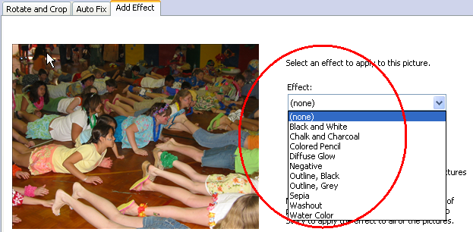

Click the dropdown menu for several special effects you may add to the picture. You may apply the same effect to all images by checking the checkbox on this screen. Click Save, then Close when you are finished.

Click Next to continue.

Adding text to your pictures
On the “Add a title to your pictures page,” click the first picture, and then type
any text you wish into the text box to the right of the picture.

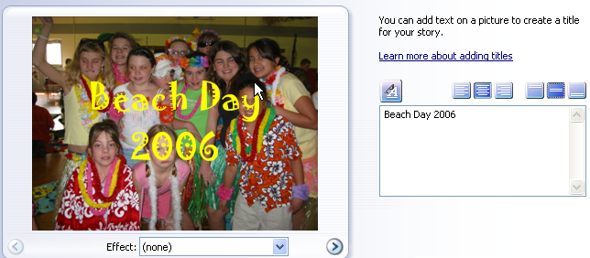

Click the Select Font button. Here you select the font, size, style, and color of the text you enter. Click the Align buttons to move the title on
the picture. When you are finished adding text to your pictures, click Next.

Narrating your pictures
To add narration to your story, you need to have a microphone attached to your
computer. A wizard will help you set up your microphone to record narration.
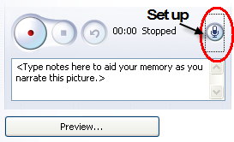

Click the Preview button to preview your script with your slideshow. There is also a text input area to create cue cards which can be a helpful memory aid when narrating your pictures.

Customizing Animation
This is where the magic begins! ☺
Click the Customize Motion underneath the picture.

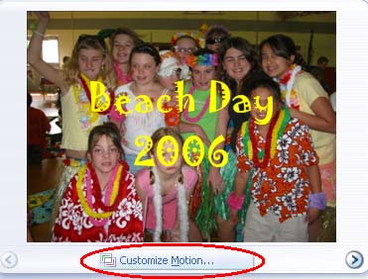

You will see the zoom setting that Photo Story has already selected. To change this, check the Specify start and end position checkbox. Then drag and resize the rectangles as desired. Click the Preview button to check out the changes you made.
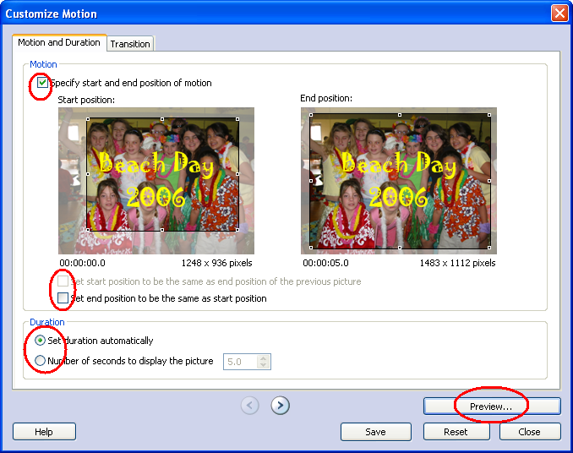

You can also adjust the number of seconds the picture is displayed.

Transitions

Click the Transition tab to change the transition from one slide to the next.

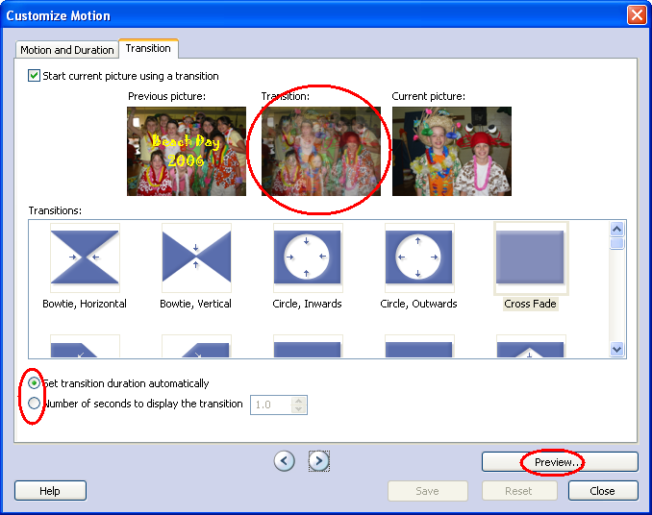

The center picture shows how the transition you selected looks when moving from one picture to the next. You can also set the number of seconds if you wish. The Preview button will let you see the changes you’ve made. When you like what you have selected, click the Save button and then click the Close button. Click Next.

Adding Background Music 
Click the first picture in the filmstrip and then click Select Music. Browse to a music file that you have saved on your computer. The music you just added is
shown as a colored bar above the picture in the filmstrip. This helps you determine which pictures will be shown for each piece of music you add. This is particularly helpful when you add more than one song to your story. To remove music, right click on the slide(s) and select Music, then Delete.
Creating Music for Your Story
Click on any picture in the film strip, and then click Create Music.

In the Genre dropdown list, make a selection. Then in the Style dropdown list, make another selection. You may choose to either leave the defaults Bands and Moods or explore the options there also. Click Play to preview the selection you’d just created. When you like your creation, click OK to close the dialog box.
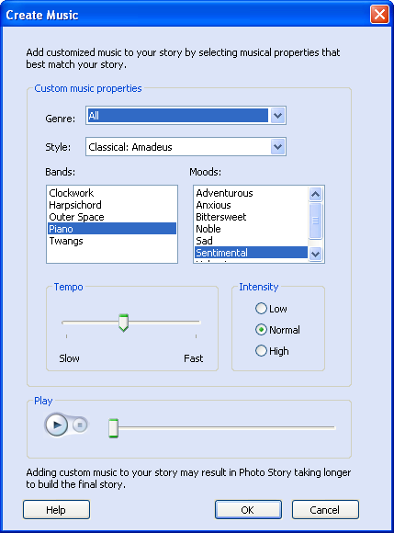

If you previously added a narration, you will see 2 colored bars above the pictures in the filmstrip. Click the first picture in the filmstrip, and click Preview, to see how well your music fits the story. You may need to adjust the music volume levels to accommodate your narration. To do this, simply click the picture in the filmstrip and then adjust the music volume using the volume slider bar. You may need to adjust the volume and preview your story a few times to get it just right. When you’re satisfied, click Next.

Saving your story
When you save your photo story, all the pictures, narrations, and music are
compiled into a video file that you can view in Windows Media Player. Since you will play this photo story on your computer, you can use the default options when saving your photo story.

Be sure to enter a location here that you will remember! ☺

Important
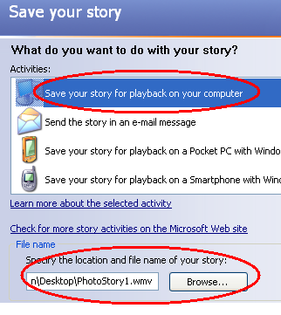

If you are not finished editing your story, you must also click the Save Project button at the bottom of the screen. Then you will be able to open it in Photo
Story again to make more changes.



